VCPD GoToMeeting
September 11, 2018 * 2:30-4:00

MEETING SUMMARY

Present
Buck, Deana  Cook, Cathy  Deluca, Tracy  Flores, Selina  Harvey, Jaye  Hendricks, Dawn  Hill, Cori  Houck, Pam | Ingram, Kristen  Kern, Cindy  Kolodzinski, Clarissa  Koon, Patricia  Meyers, Kris  Owen, Janet  Phipps, Caren  Popp, Patricia  Rakes, Susanne | Roberts, Jodi  Sopko, Kim  Stepien, Debi  Tobin, Mary  Watkins, Peggy  Webb, Katie  White, Mary Lynn  Wilberger, Sandy

Additional Funding
Sandy Wilberger announced that VDSS has agreed to allocate an additional $25,000 to support VCPD initiatives including coordinator travel and hours, VCPD 101, evaluation, and some operational expenses. In addition, some Virginia Quality funds are available to support VCPD 101 training.

VCPD 101
At this time, two VCPD 101 sessions are planned for this fall. The October training is scheduled for October 24-25 at the ODU campus in Suffolk. Registration will be through the ODU TTAC. On November 29-30, a training is planned for the GMU campus in Manassas. Initially, participant slots will be open to Virginia Quality and Smart Beginnings personnel. Registration is through the Office for Children in Fairfax.

Cross-Disciplinary Higher Education Symposium
VCPD has received financial support for a cross-disciplinary symposium for higher education faculty. Teams of faculty preparing EC, ECSE, OT, PT and SLP personnel to serve young children with disabilities and their families from Virginia universities and their community college colleagues will meet on October 4-5, 2018 at the Hilton Garden Inn in Charlottesville. As of today, 37 presenters, team members, and faculty from VCU, RU, Lynchburg, Longwood, GMU, JMU and UVA are registered. The Symposium is supported through the federally-funded Early Childhood Personnel Center (ECPC) at the University of Connecticut. VCPD Governance members have served as Virginia’s ECPC leadership team for the past five years.

Regional Consortia Mini-Retreat
Selena Flores, RC Workgroup Convener, reported on the Regional Consortia Workgroup Mini-Retreat held on August 28, 2018 at the Bon Air Library in Chesterfield. The agenda including a discussion of the history of VCPD, and the roles and responsibilities of regional consortia facilitators and CCA administrative support staff. 15 regional leaders reflected on their regional successes and challenges, and generated creative ideas for future efforts. A number of resources, available at www.vcpd.net/regional-consortia, were shared.

Inclusive Practices Task Force
Sandy Wilberger, Co-Convener of the Inclusive Practices Task Force (IPTF), noted that the IPTF met in Richmond and by GoToMeeting on July 12. The meeting focused on addressing their first action plan goal of developing a series of infographics targeted to different stakeholders. Subgroups will report back at the September 17 meeting. Additional meeting dates are November 19 and January 28.

Children’s Cabinet
Angela Wirt, Executive Director of Child Care Aware of Virginia, shared information about the Children’s Cabinet. See the PowerPoint from their recent meeting at https://www.governor.virginia.gov/media/governorvirginiagov/governor-of-virginia/childrens-cabinet/Childrens-Cabinet-Intro-Meeting.pdf. Angela is serving on the Early Childhood Development and School Readiness workgroup. The primary focus is to assure that early childhood education is affordable, high quality, and accessible across the Commonwealth.
When asked if there was any discussion related to PD at the meeting, Angela shared that PD was not specially mentioned. When asked if the needs for children with disabilities were represented, Angela shared that while there were not specific “agencies” that solely represented this population, she felt that discussions related to all children included them.
Task: Angela will keep these topics in the forefront at future meetings.
Virginia Quality/VCPD Quality Assurance
Kris Meyers, Director of Quality Improvement at VECF, shared this graphic to reflect how their thinking is evolving around QRIS TA.
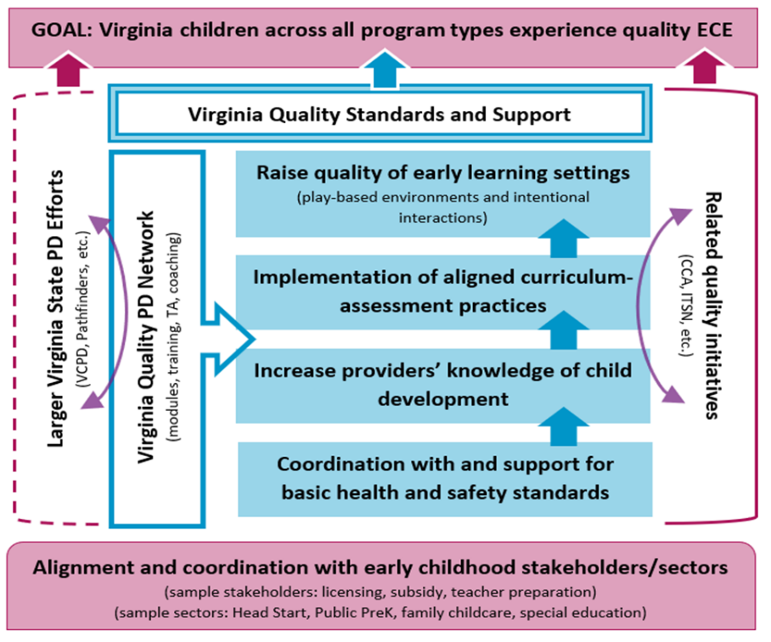

Kris also reminded us of the three quality-related goals in the VCPD Strategic Plan:
- Promote high quality professional development.
- Enhance the knowledge, skills and abilities of early childhood PD providers.
- Improve the knowledge, skills and abilities of early childhood direct service providers.
In addition, Kris noted that a survey of the PD Landscape is planned for dissemination in October. The survey is designed to be relatively brief but address the audience for PD efforts, the focus (content) of PD provided to early childhood practitioners, and the knowledge, skills, and abilities of PD providers. She anticipates being able to share the results at the December VCPD meeting.

Early Childhood Mental Health Virginia Provider Survey
Bonnie Grifa, State Early Childhood Mental Health Coordinator, planned to share the results of a recent survey of Virginia early childhood personnel regarding early childhood mental health. Bonnie was unable to present as she was busy evacuating from her home due to Hurricane Florence.

Tips for Trainers: VCPD 101, Module 4, Unexpected Numbers of Participants
Jaye Harvey shared a tip for trainers from VCPD 101, Module 4. Sometimes the number of participants expected for a training and the number who actually attend are vastly different and require the presenter to make accommodations quickly. When the group size exceeds the number anticipated, consider the following:
- Close the door. Post a Session Full sign. (for a conference session)
- Add opportunities for table or elbow partner discussions. Consider think-pair-share.
- Allow additional time for activities.
- Add movement without leaving seats.
- Move through the room as you present.
- Repeat input from participants to ensure all can hear.
When the group is much smaller than anticipated:
- Gather the participants together.
- Customize the presentation content to address needs and interests of participants.
- Change large group activities to small group activities. Small group discussions may be converted to think-pair-share with report outs.
- Add more rotations to wall chart activities.

On the Website/Announcements
Information posted on the homepage at www.vcpd.net was briefly noted.

Continuous Improvement: What worked well for our meeting today?
- Having the agenda in advance.
- Sharing information from the website.
- Don’t change a thing!
- Nice to have a bit of extra time.

Thank You
- All who participated
- Our presenters
- Peggy Watkins and Child Care Aware for use of GoToWebinar
- Sandy Wilberger and the VCU T/TAC for the conference call line and taking meeting notes

Upcoming Dates
- VCPD Meetings
October (No Meeting)
November 13 (GoToWebinar)
December 11 (Face-to-Face)

- VCPD 101
October 24-25 in Suffolk
November 28-29 in Manassas

- Inclusive Practices Task Force
September 17
November 19
January 28

