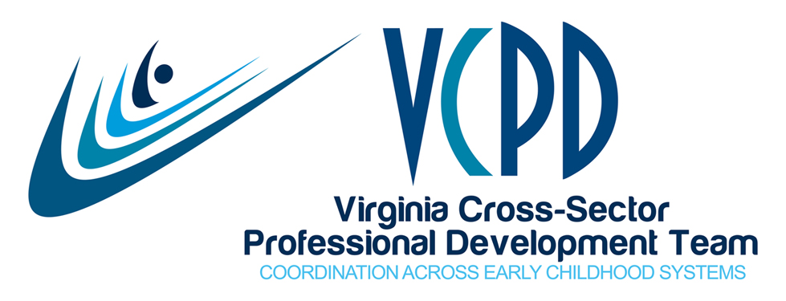
VCPD GoToWebinar Meeting
February 13, 2018
2:30-4:00

MEETING NOTES

Present
Allan, Mark  Andrews, Kimberly  Armstrong, Tatanishia  Buck, Deana  Carter, Kristi  Cook, Cathy  Daniel, Stephanie  Flores, Selina  Gregory, Kim  Griffey, Emily  Jaye Harvey  Henderson, Cheryl  Hendricks, Dawn | Hill, Cori  Houck, Pam  Ingram, Kristen  Jackson, Sakina  Kern, Cindy  Kolodzinski, Clarissa  L’hospital, Ann  McCartney, Holly  Meyers, Kris  Owen, Janet  Petrowicz, Tammy | Phipps, Caren  Popp, Patricia  Rakes, Susanne  Stepien, Debi  Tobin, Mary  Thomason, Kim  Watkins, Peggy  White, Mary Lynn  Wilberger, Sandy  Wiley, Lynn  Williams, Alyson  Williams, Mira Cole
Opening Poll
The meeting opened with a quick poll about our least favorite aspect of offering professional development. The results:
61% Technology that worked before the session but not during.
33% Hauling all the materials in and out.
17% Reading evals complaining about the room temp and food.

Updates: Inclusive Practices Task Force
Dawn Hendricks updated members on the Inclusive Practices Task Force (note name change from Inclusive Practices Workgroup). The IP Task Force met in person in Richmond and by GoToMeeting on February 7. They adopted a set of guiding principles for their work, and completed a final draft of an action plan. IP members also provided input into an Inclusive Practices Guidance document currently under development by the VDOE.
Quality Assurance
Kris Meyers, new convener of the QA Workgroup, thanked Stephanie Daniel for her past leadership of the Workgroup. They met at the VCPD face-to-face meeting on December 12. At this time their efforts will support the work of Virginia’s Effective Technical Assistance Quality Rating and Improvement System (QRIS) Peer Learning Group (TA PLG). Members are Kris, Katie Squib, Kathy Gillikin, Sandy Wilberger, and Jaye Harvey. Virginia will focus on Approaches to Implementation and Scale and Data Collection, Accountability, Monitoring and Evaluation.

Regional Consortia
The Regional Consortia met via conference call before the VCPD meeting today. Summits are planned as follows:
- Western: April 18 in Wytheville
- Northern: May 2 in Manassas
- Eastern: May 9 in Hampton
- Central: June 14 in Richmond
- Piedmont: TBD
In addition, RC members have supported regional VCPD 101 opportunities. VCPD 101 was offered in the Central region at ChildSavers in Richmond on January 4-5 with 9 participants. Seventeen were registered but snow made some people unable to participate. Piedmont will host a training on March 1-2 at JMU in Harrisonburg. There are 22 participants registered. Others may register with Pam Houck at Pfhouck@sentara.com. Northern will offer VCPD 101 on June 21-22 at the Rappahannock United Way in Fredericksburg. Registration will open at a date closer to the event.

Governance Workgroup
Sandy Wilberger shared information about the Governance Workgroup. Governance meets the first Tuesday of the month via GoToMeeting. A half-day retreat is planned for March 6 to focus on updates to the Strategic Plan. They:
- Oversee the management of VCPD.
- Secure continued funding.
- Coordinate the partnership agreement.
- Maintain communication with state level agencies and organizations.
- Serve as the Early Childhood Personnel Center Leadership Team.
Members are Mark Allan, Laurel Aparicio, Deana Buck, Bethany Geldmaker, Kathy Gillikin, Jaye Harvey, Dawn Hendricks, Cori Hill, Aleta Lawson, Peggy Watkins and Sandy Wilberger.

Organizational Chart and Brochure
Jaye shared that the organizational chart and VCPD brochure have been updated. Both can be found at www.vcpd.net under About.

Agency Focus: ChildSavers
Cindy Kern and Kristi Carter shared information regarding their agency. Click this link to view the PowerPoint posted on the VCPD website under Organizations.
http://www.vcpd.net/childsavers/

Tips and Tricks for Trainers
Jaye shared two tips for trainers from VCPD 101 based upon Bob Pike’s Creative Training Techniques. Increasing retention of information is key for transfer of learning to practice.
- Research from the University of California notes that in 30 days, people remember less than 10% of what they heard one time. They recall 90% of what they hear six times with interval reinforcement.

- The 90/20/8 Rule states that most adults can listen with understanding for 90 minutes, and can listen with retention for 20 minutes. Therefore, no module should exceed 90 minutes, there should be a change of pace every 20 minutes, and participants should be involved with the content every 8 minutes

Website Update
Jaye noted that a number of impactful reports have been released recently and links are posted at www.vcpd.net. These include Early Impact Virginia, JLARC, Children’s Budget, Virginia Early Childhood Workforce, Governor’s Early Childhood Cabinet, and Blueprint Virginia/Chamber of Commerce.
VECF hosted a webinar on February 5, 2018 sharing results of the Workforce Survey. A link to the archived webinar is on the VCPD website. With regard to professional development, 63% of lead teachers and 67% of directors/administrators listed behavior management as their greatest need for PD. Social emotional development and learning was the second most requested topic. Regarding delivery mode, 65% of lead teachers were interested in online modules/videos and 63 % preferred in person trainings (participants could choose more than one mode of delivery).

Announcements
- The VDSS contract to provide $25,000 in financial support for VCPD continues to work its way through VCU and VDSS.

- While the CCSS Conference will no longer be a VCPD event, early intervention and early childhood special education staff are working on a return to Hotel Roanoke in July 2019. Cori Hill indicated that she has been to Roanoke to begin the work of getting a contract in place.

- VCPD will exhibit at the Children’s Mental Health Symposium on March 14th in Williamsburg. Registration is full, but they are accepting a waiting list.

- Kimberly Andrews announced that Celebrating Babies and Tots has scheduled four trainings: March 10 in Staunton, March 24 in Reston, April 14 in Fredericksburg, and April 28 in Hampton. The keynote presentation is about early brain development. A link to registration is on the VCPD homepage.

- Mark Allan shared information regarding the VPI+ grant. Virginia was awarded $1,375,218 in supplemental Preschool Development Grant (VPI+) funds which will support:
- Addition of 5 new VPI+ classrooms in the 2018-19 school year.
- Two UVA early childhood courses offered free of charge to VPI teachers (limited spaces available)
- Data integration work at the state level
- Improvements to VPI programs in participating divisions
VPI Coordinator Institutes are being held in 4 locations across the state in March/April and an Early Childhood Educators Institute for VPI+ and VPI teachers is planned for July 17-18, 2018. Recent VPI+ data reveals that almost 10,000 children (at least, given turnover in slots) and families have received a high quality start to their education through the VPI+ grant. Additionally, progress is being made for including students with disabilities in regular preschool classroom settings. QRIS scores in VPI+ have improved with significant changes to classroom environments and interactions between teachers and students.
- Dawn Hendricks updated members on the Virginia Tiered Systems of Supports (VTSS) and early childhood. The state General Assembly provides funding for VTSS. VTSS has primarily been a K-12 initiative, but there are efforts in place to extend to early childhood. Recently, an application for a grant (up to $50,000) was released to school divisions that have been doing VTSS and doing it with quality. The grant is for the divisions to expand VTSS into early childhood and/or mental health. Applications are due 2/16/18.

Dawn also announced that the VDOE and VDSS have worked together to develop guidelines for the prevention of suspension and expulsion in early childhood. The guidelines were recently approved by the Board of Education and can be found on the VDOE website at http://www.doe.virginia.gov/instruction/early_childhood/index.shtml

General Assembly Update
Emily Griffey, Policy Director at Voices for Virginia’s Children, was our guest speaker. She stated that February 13 (date of VCPD meetings) was crossover day at the General Assembly (GA). All bills still under consideration cross over to the other side of the GA. Some good ideas regarding early childhood will not cross over as they need more time to be vetted, however; the concepts have been introduced for future work. The First Lady has a strong interest in early childhood and they await her platform.
The federal budget released on Friday included doubling of CCDBG funding. In Virginia, this could mean around $40-60 million at the state level. VDSS will open a process for input on the state plan this spring.
The General Assembly budget report will be released this Sunday. Could possibly include Medicaid expansion funds that might support additional behavioral health care services. Proposals have been submitted around trauma informed care and a workgroup across agencies is proposed to define the direction this might take. This group is recommending more PBIS in ECE.
A number of the budget amendments related to the JLARC report have shown bipartisan support. Voices has provided feedback on which might be the most impactful. One amendment involves a plan for the expansion of preschool across public and private setting to assist in ramping up the quality of these programs and allow more children to be served.
GA action on childcare includes extending the finger print background checks for two years. VDSS is covering costs for the first year of checks.
Future dates for Full VCPD Meeting
- March 13: Face-to-Face Meeting at the Twin Hickory Library in Henrico (NOT Tuckahoe) from 10:00-3:00

- April 10: GoToWebinar Meeting from 2:30-4:00

- May: No full VCPD meeting is planned for May due to the regional summits happening in the April, May, June timeframe.

- June TBD: Due to a recently discovered conflict for the ECPC team with our usual second Tuesday of the month meeting schedule, the planned face-to-face meeting on June 12th (10:00-3:00) will be changed, Stay tuned for a final decision from Governance. Most likely June 5th.

Continuous Improvement
- What worked today:
  - Emily giving us updates and is a voice for our field to the General Assembly.
  - Well organized and moves along.
  - Agency spotlights are helpful.

- What needs improvement:
- Nothing noted.

