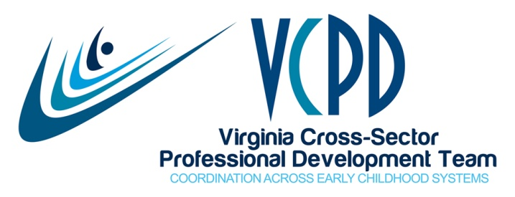

MEETING SUMMARY
August 9, 2016

Present
Buck, Deana  Cacace-Beshears, Toni  DeLuca, Tracy  Grossman, Robin  Harvey, Jaye  Kennedy, Pat  Kern, Cindy | Kotz, Megan  Lange, Karen  L’hospital, Ann  Liberman, Donna  Meyers, Kris  Miller, Brandi | Owen, Janet  Rakes, Susanne  Roberts, Jodi  Smith-Basey, Sharon  Taylor, Kimberly  Watkins, Peggy

Welcome
We welcomed two new members, Caren Phipps and Tracy DeLuca, from the Department for the Blind and Vision Impaired.

VCPD Higher Education Faculty Institute
Registration is open for the VCPD Faculty Institute to be held on September 29-30, 2016 at the Doubletree in Charlottesville. Holly Coy, Deputy Secretary of Education will be the opening speaker and will discuss the School Readiness Committee. Dr. Pam Winton is our keynoter for Friday. Friday’s work will center on preparing early childhood practitioners to work in inclusive settings.

Creating Connections to Shining Stars
The contract for Hotel Roanoke is almost through the VCU approval process. A save-the-date is being developed to go out once the contract is final. The CCSS Workgroup has begun regular meetings with subcommittee leadership in place. Conference dates are July 19-21, 2017.

Quality Assurance Workgroup
Donna Liberman reported that the QA Workgroup will meet by conference call on September 19th from 2:00-3:30. They will begin work on a trainer approval process. New workgroup members are invited to attend. QA is in the process of piloting the document regarding choosing a professional development provider. They have created a comprehensive document as well as a simpler, abbreviated version. Contact Donna if you know of a center director who may be willing to participate in the pilot.

Early Childhood Personnel Center
Deana Buck reviewed the draft ECPC work plan and noted how that plan “connects the dots” between VCPD and ECPC. Deana was to represent Virginia on an ECPC panel at the recent OSEP conference in Washington, DC; however, no participants attended the session. She was pleased to be able to use the time to network with the DC representatives and learn about their strategies to build an infrastructure for inclusion.

School Readiness Committee
No state level VCPD members were appointed to the School Readiness Committee (SRC); however, several faculty members who participate in regional consortia and/or attended the 2016 VCPD Faculty Institute were selected. The SRC has had one phone meeting and will hold their initial face-to-face meeting in Richmond on September 8, 2016. SRC information is available at https://education.virginia.gov/initiatives/school-readiness-committee/

Support for Regional Consortia
Kimberly Taylor from Child Care Aware apologized for the recent changes, but noted that funding to the five VCPD Regional Consortia has been restored. This funding provides 12 hours per month of administrative support, $2000 for regional activities including summits, and $1000 for scholarships for the CCSS conference next Summer.

Changes in VCPD Coordinator’s Work
Due to federal grant funding through the Health Department that ends this September, Jaye will now work an average of 26 hours per week.

Child Care Aware and the Shared Services Network
Jodi Roberts described the Virginia Shared Services Network (http://www.vasharednetwork.org/default.aspx) and invited VCPD members to join in order to access this free resource. Virginia is one of 26 states to have this platform, and it has a wealth of information and tools useful across a broad range of early childhood programs.

Continuous Improvement
Thanks to Child Care Aware for hosting our GoToWebinar meeting, and to Jodi for her presentation on the Shared Services Network.

Upcoming VCPD Meetings
- September 13
- October 11 (Face-to-Face at the Tuckahoe Library)
- November 8
- December 13 (Face-to-Face)

Upcoming VCPD Events
- VCPD Faculty Institute: September 29-30, 2016 in Charlottesville
- Creating Connections to Shining Stars: July 19-21, 2017 in Roanoke (Refrain from widely publicizing until hotel contract is finalized through VCU.)

