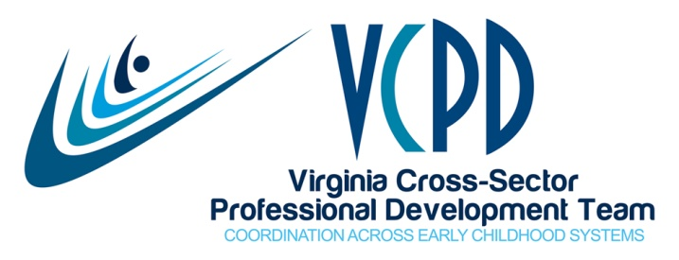

VCPD Meeting Summary
April 12, 2016

Present
Cacace-Beshears, Toni  Flores, Selina  Gillikin, Kathy  Griffey, Emily  Grossman, Robin  Harvey, Jaye  Hendricks, Dawn  Hill, Cori  Hooper, Belinda | Ingram, Kristen  Kern, Cindy  Lange, Karen  Liberman, Donna  Mahmood, Sue  Meyers, Kris  Miller, Brandi  Owen, Janet  Roberts, Jodi | Ruffin, Novella  Smith-Basey, Sharon  Stepien, Debi  Taffe, Ipek  Veatch, Sharon  Watkins, Peggy  White, Mary Lynn  Wilberger, Sandy  Wiley, Lynn  Williams, Mira Cole

VCPD Initiatives
- Higher Education Faculty Institute
Jaye shared that we are planning for a second Higher Education Faculty Institute on September 29-30 at the Doubletree in Charlottesville. This year, we will be at a larger site in order to accommodate up to 75 faculty members. A Save-the-Date will be distributed soon.

  - Creating Connections to Shining Stars Conference
The contract is now with Hotel Roanoke and will soon go to the VCU event planner for moving through the procurement process. Once the contract has been signed, we will move forward with a Save-the-Date. The CCSS Workgroup is in place and will begin to meet soon.

Task: Please remind people in your organization that the conference is now held biannually.

  - VCPD 101 Presentation at VAECE
VCPD was invited to offer a pre-conference day at VAECE. Peggy, Leslie, and Jaye delivered the training on Modules 1-3 of VCPD 101. Those in attendance indicated they were very pleased via the evaluations.

  - Strategic Plan
The final document was e-mailed to all on April 6^{th,} and is also posted to the VCPD website. Each workgroup should begin reviewing the plan in order to start working on their identified goals and objectives.

Outcomes of the 2016 General Assembly Session
Emily Griffey, Senior Policy Analyst at Voices for Virginia’s Children, shared information regarding HB 46 and HB 47 both filed by Delegate Greason and passed by the General Assembly. HB 46 ultimately established a School Readiness Committee that has professional development of the early childhood workforce as a focus. HB 47 created grant funding for a mixed delivery preschool pilot program. The Governor funded HB 47 at 1.5 million per year. The plan is for pilots in six communities to explore models using private and public classrooms. VECF is leading this initiative and has posted applications for interested localities. A one page description is on the VCPD website. Emily suggested that VCPD members encourage localities to participate in the pre-conference discussion and to submit a proposal. An amendment has been submitted seeking waivers from the Board of Education (BOE) so that localities would not have to meet the teacher qualification requirements established by the BOE. The General Assembly convenes next week and will discuss this further.

HB 46 established the School Readiness Committee (SRC) which will be a more permanent early childhood committee to replace the Commonwealth Council on Childhood Success (CCS). Historically, in Virginia committees such as the CCCS have been dependent on the current administration and hence come and go. The legislation describes membership on the SRC; however, invitations are circulating seeking nominations for the Committee and VCPD has been invited to nominate three applicants. Applicants will go through the official governmental process including completion of an online application.

Task: Jaye to share information with VCPD Governance in order to identify our nominees and complete the nomination process.

The “take away” from General Assembly session is that in the past there were concerns that conservatives would not view ECE favorably, but this year they did. Both sides did what they felt was in the best interest for young children. Budget wise, ECE had many budget successes with very strong bipartisan support. Go to http://www.vakids.org/ for more information about legislative wins.

Spotlight: Military Child Care
Karen Lange, Military Child Care Liaison, shared information about military child care. See the attached PowerPoint.

Continuous Improvement
- Information shared from Military Child Care was very informative
- No improvements noted.

Upcoming VCPD Meetings
- May 10: GoToMeeting (Note: This meeting was subsequently cancelled.)
- June 14: Face-to-Face at the Libbie Mill Library (2100 Libbie Lake East St.)
- July: No meeting planned
- August 9: GoToMeetinng
- September 13: GoToMeeting
- October 11: Face-to-Face

Upcoming VCPD Events
- Central Consortium Summit: April 29 in Richmond
- Northern Consortium Summit: May 19 in Manassas
- Western Consortium Summit: May 20 in Wytheville
- Piedmont Consortium Summit: June 15 in Lynchburg

